WEEK 4 PROJECT REPORT
Exploratory Data Analysis (EDA)
Exploring Customer Feedback and Product Sentiment
Internship | Data Science with Python Analyst Internship
Domain | Beauty & Wellness
Week | Week 4
Submission date | 13 October 2026
Analysis focus | Ratings, missing values, review-length patterns
This report records the workflow, quantitative findings, visualizations, output files, quality checks, limitations, and next steps.

Report Navigation
Sections cover the executive summary, project context, objectives, dataset structure, methodology, tools, missing values, rating analysis, chart interpretation, review-length analysis, output files, reproducibility, limitations, next steps, and final submission checklist.

1. Executive Summary

Purpose of this phase
Week 4 covers Exploratory Data Analysis (EDA) for the internship project “Exploring Customer Feedback and Product Sentiment” in the Beauty & Wellness domain. EDA is the stage in which the prepared dataset is examined before deeper statistical work or sentiment modelling begins. The focus is to understand the dataset’s structure, review-rating frequencies, review-text lengths, missing-value profile, and the outputs generated by the Python script. The goal is not to make unsupported claims about product quality, but to describe what is visible in the dataset and establish a dependable starting point for later analysis.

Work completed
The supplied `eda_analysis.py` script reads the cleaned review CSV using Pandas; prints its shape, column names, data types, DataFrame information, and descriptive statistics; checks that `rating` and `text` columns exist; exports a missing-value summary; converts ratings to numeric values; counts each rating; calculates character length for every review; exports rating and length summaries; saves a dataset with the new `review_length` field; and creates a bar chart and histogram with Matplotlib. The terminal screenshot shows that the script reached “EDA completed successfully!” and exited with code 0.

Headline observations
The terminal screenshot reports 693,443 rows. Rating counts are 100,752 for one star, 42,576 for two stars, 55,687 for three stars, 78,532 for four stars, and 415,896 for five stars. The values sum to 693,443. Five-star reviews are the largest group, representing approximately 60.0% of the rows shown. The review-length output reports 693,443 observations, a mean of 173.30 characters, a median of 102, a standard deviation of 247.24, a 25th percentile of 4, a 75th percentile of 209, and a maximum of 14,989 characters.

Important consistency note
The earlier draft report and README contained conflicting values: 69,343 rows instead of 693,443, and a maximum review length of 1,489 instead of 14,989. The supplied terminal screenshot supports the larger figures. The final submission should use figures from one fresh run of the script and cross-check the CSV exports against the charts. This report makes that discrepancy explicit rather than hiding it.

2. Project Background and Business Context

Why customer feedback matters
Customer reviews can reveal how people describe their experiences with beauty and wellness products. Reviewers may mention texture, scent, packaging, ease of use, value for money, delivery, perceived effectiveness, irritation, or whether a product met expectations. A star rating offers a compact summary of a reviewer’s evaluation, while written text may provide context for that score. Combining structured ratings with text can therefore support a more detailed understanding of the feedback present in a dataset.

Business problem
A large review file is difficult to interpret by simply opening it in a spreadsheet. The project needs a repeatable method to answer basic questions: How many review records are available? Which fields can be analyzed? How are ratings distributed? Are review texts usually short or long? Are there missing values that could affect later work? Which output files preserve the findings? These questions must be addressed before any model or business recommendation is attempted.

Role of exploratory analysis
EDA turns a raw or cleaned dataset into a set of descriptive summaries and visual evidence. It can identify dominant categories, skewed distributions, missingness, unexpected values, and potential data issues. EDA does not by itself establish why a pattern exists, prove causation, or show that the sample represents every customer. Interpretations must remain limited to the dataset and checks actually performed.

Scope of Week 4
This phase includes dataset inspection, descriptive statistics, missing-value counting, rating frequency analysis, review-length calculation, chart creation, and export of summary CSV files. It does not include a trained sentiment classifier, topic modelling, product-level ranking, causal analysis, or a validated prediction system. Those are separate activities requiring their own methodology and evidence.

3. Objectives, Scope, and Success Criteria

Primary objective
The primary objective is to conduct a reproducible first exploration of the cleaned Amazon Beauty customer-review dataset and document the results in a form that can be reviewed by an internship evaluator.

Specific objectives
The script is designed to load the prepared CSV, verify that the required `rating` and `text` columns exist, print dimensions and schema information, produce descriptive statistics, calculate missing-value counts, count ratings by category, calculate review length in characters, export the summaries, generate two visualizations, and save an enriched copy of the data. Each output should be reproducible from the script rather than manually typed into a report.

In-scope tasks
The work includes basic data inspection and descriptive visualizations. A required-column check prevents the script from continuing when essential fields are absent. Rating conversion uses numeric coercion so values that cannot be parsed become missing rather than causing an immediate conversion error. Review-length calculation fills missing text with an empty string before converting values to strings and counting characters.

Out-of-scope tasks
The script does not verify the authenticity of reviews, determine whether every rating is justified, identify all languages, measure sentiment strength, or train a machine-learning model. It also does not prove that missing data is random. These limits should be stated so that descriptive outputs are not mistaken for more advanced conclusions.

Success criteria
Operational completion means the file loads, required columns are found, the script reaches its completion message, output CSV files are written, and both charts are saved. Analytical completion additionally requires consistency checks: the rating counts should agree with the rating summary CSV, the total counts should be explainable from the dataset, and the histogram’s range should agree with the review-length summary. A successful program exit alone does not guarantee that every interpretation in a report is correct.

4. Dataset Overview and Structure

Input file and project layout
The script reads `data/processed/beauty_reviews_cleaned.csv`. The path is built from the location of the script, so the project folders need to retain the expected relationship. The analysis creates `visuals/` and `data/processed/` output directories when they are absent. The input CSV itself must already exist at the configured location; creating an output directory cannot replace a missing source dataset.

Fields used in this analysis
The two fields directly required by the script are `rating` and `text`. The `rating` field is converted to numeric form and used to count ratings. The `text` field is used to calculate review length. Other columns may include title, images, product identifiers, user identifiers, timestamp, helpful votes, and verified-purchase information, but the current printed column list should be treated as the final authority if the file differs from this general project description.

Row count and version mismatch
The terminal screenshot states “Total Dataset Rows: 693443” and “Total Ratings: 693443.” The rating category counts also sum to 693,443. An older draft README and report contained 69,343, which is inconsistent with the supplied screenshot. This could be a stale report, a different data version, or a transcription error. It should not be resolved by guessing; rerun the current script and inspect `df.shape` and the output CSV files.

Why schema inspection matters
Printing column names and data types is a simple but valuable quality-control step. It confirms that the file has the expected fields and helps reveal whether a field has been loaded as numeric, text, or another type. A rating column loaded as strings can cause ordering or aggregation problems unless converted. A review-text field containing nulls needs a defined policy before length calculation or text processing.

Dataset limitations
The dataset represents reviews included in the supplied file, not necessarily every purchase or every customer experience. The current EDA does not examine sampling methods, review authenticity, temporal coverage, or product representation in detail. Conclusions should therefore be phrased as observations about the analyzed records rather than universal statements about all Beauty & Wellness products.

5. Methodology and Processing Workflow

Step 1 — Load the CSV
Pandas reads the input CSV with `low_memory=False`. The script prints a success message, dataset shape, column names, and data types. These messages make the run easier to inspect and help identify path or parsing problems early. If the file cannot be found or read, the script will stop before generating its outputs.

Step 2 — Validate required columns
The script checks whether `rating` and `text` are present. It collects any missing required column names and raises a `ValueError` if the schema is incomplete. This is preferable to allowing later operations to fail with a less informative error. For stronger validation, the script could also check that the rating field contains only allowed values and count any ratings that became null during conversion.

Step 3 — Inspect and summarize
The script calls `df.info()` and `df.describe(include='all')`. These outputs provide an overview of non-null values, data types, and descriptive statistics. It then calculates missing values with `df.isnull().sum()`, converts the result to a two-column table, and writes `week4_missing_values_summary.csv`. Missing counts identify where values are absent, although they do not explain the cause or impact of missingness by themselves.

Step 4 — Count ratings
The rating field is converted with `pd.to_numeric(errors='coerce')`, then counted with `value_counts()` and sorted by rating. The counts are printed and exported to `week4_rating_distribution.csv`. The same series is plotted as a bar chart. Since the data is discrete and ordered from one to five stars, a bar chart is an appropriate first visualization.

Step 5 — Calculate review length
The expression `df['text'].fillna('').astype(str).str.len()` creates a character count for each review. Null text is temporarily treated as an empty string for this calculation. Character count is not the same as word count, token count, reading time, or sentiment. The resulting summary is generated with `describe()` and exported to `week4_review_length_summary.csv`.

Step 6 — Save data and figures
The script writes a copy of the data with the calculated `review_length` field to `week4_reviews_with_length.csv`. It saves the rating chart and length histogram in the `visuals/` folder at 300 DPI, then prints the output paths and a success message. A final check should verify that the files were generated during the latest run rather than being leftover from an earlier execution.

6. Tools and Technical Environment

Python
Python provides the execution environment for the analysis script. The supplied evidence shows a successful execution but does not establish a definitive Python version for this Week 4 run. The version should be recorded directly with `python --version` if the submission requires exact environment details.

Pandas
Pandas is used to load the CSV, inspect columns and types, calculate missing-value counts, convert rating values, count rating categories, calculate text lengths, generate descriptive statistics, and export results. It is the primary data-manipulation library in this workflow.

Matplotlib
Matplotlib generates the rating bar chart and review-length histogram. The script sets titles and axis labels, uses `tight_layout()` to improve spacing, saves the charts at 300 DPI, and closes each figure after saving. Closing figures is a good practice in scripts because it releases plotting resources between charts.

Visual Studio Code
The supplied screenshot shows the project open in Visual Studio Code. The editor is used to inspect `eda_analysis.py`, run it, and view terminal output. The chart images are also available as separate files so they can be inserted into the report or reviewed independently.

Dependency accuracy
The uploaded script imports Pandas and Matplotlib. Seaborn appears in the older README tool list but is not imported in this specific script. The Week 4 README should list the libraries actually required by the script, while any broader project dependencies should be clearly separated from direct dependencies for this week.

Reproducible setup
To check the environment, run `python --version` and `python -m pip show pandas matplotlib`. To install the direct dependencies, use `python -m pip install pandas matplotlib`. These commands are suggested for reproducibility; the report does not claim specific installed versions unless they are captured from the actual environment.

7. Dataset Inspection and Missing Values

Dataset information
The script prints `df.info()` to display column names, non-null counts, data types, and memory usage. This helps assess whether the loaded file resembles the expected cleaned dataset. The script also prints general descriptive statistics. The detailed output is useful for debugging and documenting the state of the data before more specialized analysis begins.

Missing-value summary
The missing-value summary is exported as `data/processed/week4_missing_values_summary.csv`. It should be inspected after each fresh run. The supplied screenshot does not expose the complete per-column missing-value table, so exact missing counts for every column are not asserted in this report. The correct source for those values is the generated CSV from the final execution.

Meaning of missing values
A null value can have different implications depending on the field. Missing review text can prevent meaningful text analysis, whereas a missing optional image may not affect rating analysis. A missing title may be acceptable for some tasks but could matter for title-based text analysis. EDA should report the counts and leave field-specific handling decisions to the analysis requirements.

Rating conversion and validation
Numeric coercion can transform unexpected text values into missing values. For robust quality assurance, a future script revision should count how many ratings are null after conversion and explicitly check the allowed rating set of 1, 2, 3, 4, and 5. It should also distinguish valid non-null ratings from all rows, because the total of rating counts may differ from the row count if invalid or missing ratings exist.

Text quality checks
The current review-length calculation handles null values but does not separately report empty or whitespace-only reviews. Week 3 reportedly removed blank review text, but the Week 4 script should still be considered a separate execution whose input quality needs confirmation. A useful extension would count empty strings and whitespace-only strings before calculating length, and optionally flag unusually long reviews for inspection without automatically deleting them.

8. Rating Distribution: Quantitative Findings

Exact counts from the terminal screenshot
The terminal screenshot lists 100,752 one-star reviews, 42,576 two-star reviews, 55,687 three-star reviews, 78,532 four-star reviews, and 415,896 five-star reviews. Adding these values gives 693,443, which matches the displayed total rating count and total dataset row count. This agreement is an important internal consistency check for the rating frequency output.

Approximate proportions
Based on 693,443 total records, one-star reviews represent approximately 14.53%, two-star reviews 6.14%, three-star reviews 8.03%, four-star reviews 11.33%, and five-star reviews 59.98%. The percentages are rounded to two decimal places. They are derived from the counts shown in the screenshot and should be recalculated automatically from the final CSV if the dataset changes.

Dominant five-star category
Five-star reviews are clearly the most frequent category, accounting for about three-fifths of the records shown. This imbalance is visible in the bar chart and is also evident in the raw counts. One-star reviews are the second most frequent category, while two-star reviews are the least frequent among the five categories in this output.

Interpretation boundaries
A high number of five-star reviews means that five-star ratings are common in this dataset. It does not prove that every product is high quality, that the reviews are representative of all customers, or that review authenticity has been assessed. Rating frequencies may reflect which products are included, who chooses to leave a review, platform design, or other factors not tested in this phase.

Implications for later modelling
If ratings are later converted into sentiment labels—for example, grouping one- and two-star reviews as negative and four- and five-star reviews as positive—the label distribution will be uneven. Any such grouping must be justified and documented, and neutral three-star reviews require an explicit policy. A later classifier should be evaluated with class-wise precision, recall, F1-score, and a confusion matrix rather than relying on overall accuracy alone.
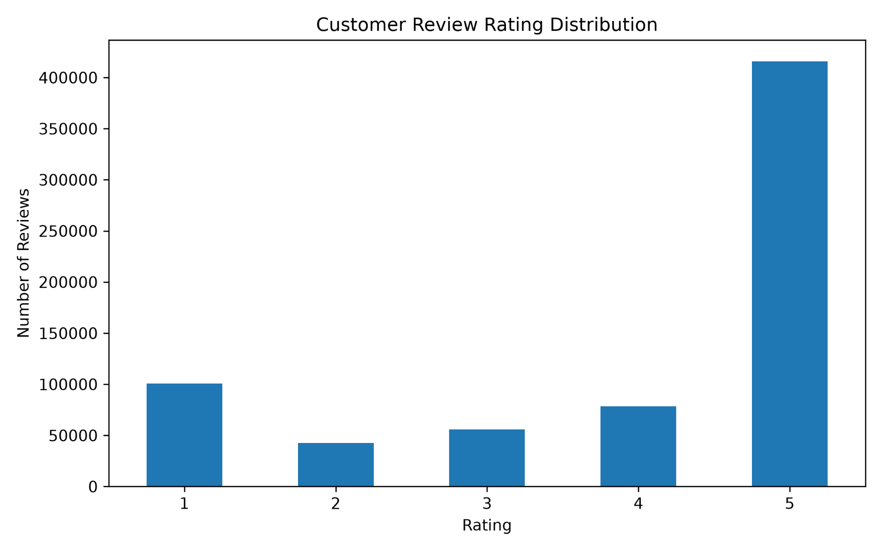
Figure 1. Rating distribution from the supplied Week 4 execution evidence.

9. Rating Visualization and Interpretation

Purpose and design
The chart titled “Customer Review Rating Distribution” compares the frequency of ratings from one to five stars. The x-axis represents the rating category, while the y-axis represents the number of reviews. The script sorts the rating counts by rating value before plotting them, making the bars appear in a natural one-to-five sequence.

What the supplied chart communicates
The five-star bar is much taller than the other bars, clearly communicating the dominant category. The one-star bar is noticeably higher than the two-, three-, and four-star bars, while the two-star category is the smallest. The visualization gives a quick visual check of the numeric table and helps an evaluator understand the main finding without reading every count.

Strengths of the current visualization
The chart uses an appropriate type for discrete categories, includes a descriptive title, labels both axes, and uses zero rotation for the rating labels. Saving at 300 DPI is suitable for inclusion in a report. The code also applies a tight layout to reduce clipping around the labels.

Possible improvements
A future version could place exact counts above each bar and create a second plot showing percentages. A percentage chart can help compare distributions between datasets of different sizes. If charts are used in a presentation, a brief annotation stating the total sample size would make the denominator clear. These are improvements rather than claims that the supplied chart already contains them.

Reproducibility
The chart is saved to `visuals/week4_rating_distribution.png`. The report should only include the latest generated image, not an older copy from a previous run. The rating CSV and chart should be produced from the same input file and execution so that the counts remain aligned.

10. Review Length: Quantitative Findings

How length is measured
Review length is calculated by counting characters in the text field after null values are replaced with an empty string and values are converted to strings. This is a straightforward, reproducible measure. However, a character count can include letters, spaces, punctuation, emoji, and other symbols. It should not be described as a word count.

Statistics from the terminal screenshot
The screenshot reports 693,443 review-length observations. The mean is 173.304723 characters, standard deviation 247.244966, minimum 1, 25th percentile 4, median 102, 75th percentile 209, and maximum 14,989 characters. These statistics describe the length distribution for the data processed in the displayed run.

Median and quartiles
The median of 102 characters means the middle of the ordered distribution lies at about 102 characters. The 25th percentile of 4 indicates that roughly one quarter of observations are at or below four characters; the 75th percentile of 209 indicates that roughly three quarters are at or below 209 characters. The small first quartile and larger upper quartile show that review lengths vary substantially.

Mean and standard deviation
The mean is higher than the median, and the standard deviation is larger than the mean. This pattern is consistent with a right-skewed distribution in which a relatively small number of long reviews increase the average. The histogram also shows a long tail extending far beyond the dense cluster of shorter reviews.

Why the maximum matters
The maximum displayed in the terminal is 14,989 characters. An earlier draft used 1,489, which conflicts with the supplied terminal output and the histogram scale. The figure of 14,989 should be used only after a fresh run confirms that the same input dataset produced both the summary and chart. Long reviews should be inspected rather than automatically discarded based only on their length.

11. Review Length Histogram and Interpretation

Purpose of the histogram
A histogram groups numerical values into intervals, or bins, and displays how many observations fall within each interval. It helps reveal concentration, spread, skewness, and the presence of a long tail. The script uses 50 bins and adds black edges to the bars to make the bin boundaries easier to see.

Observed shape
The supplied histogram has a large concentration of reviews near the lower end of the length scale. The bar heights decrease as length increases, and a relatively small number of reviews extend far to the right. This visual pattern is consistent with the reported mean exceeding the median and the maximum being much larger than the 75th percentile.

Axis and range validation
The histogram’s horizontal axis extends to around 15,000 characters, which is consistent with the terminal maximum of 14,989. The old report’s 1,489-character maximum was therefore likely stale or incorrect. The safest final procedure is to regenerate the chart and summary in one run and verify that the reported maximum agrees with the data used to draw the histogram.

Effect on interpretation
Because the distribution has a long tail, the full-range histogram compresses the differences among shorter reviews. This is not an error; it is a consequence of showing both common short reviews and rare long reviews on the same axis. A supplementary plot restricted to a clearly stated range could show short-review detail, but the full-range plot should remain available so that the outliers are not hidden.

Possible next analysis
Further review-text analysis could compare length by rating, calculate word counts, examine length percentiles, or inspect a sample of extremely long reviews. Those tasks are not part of the current script and should be recorded as future work rather than represented as completed results.
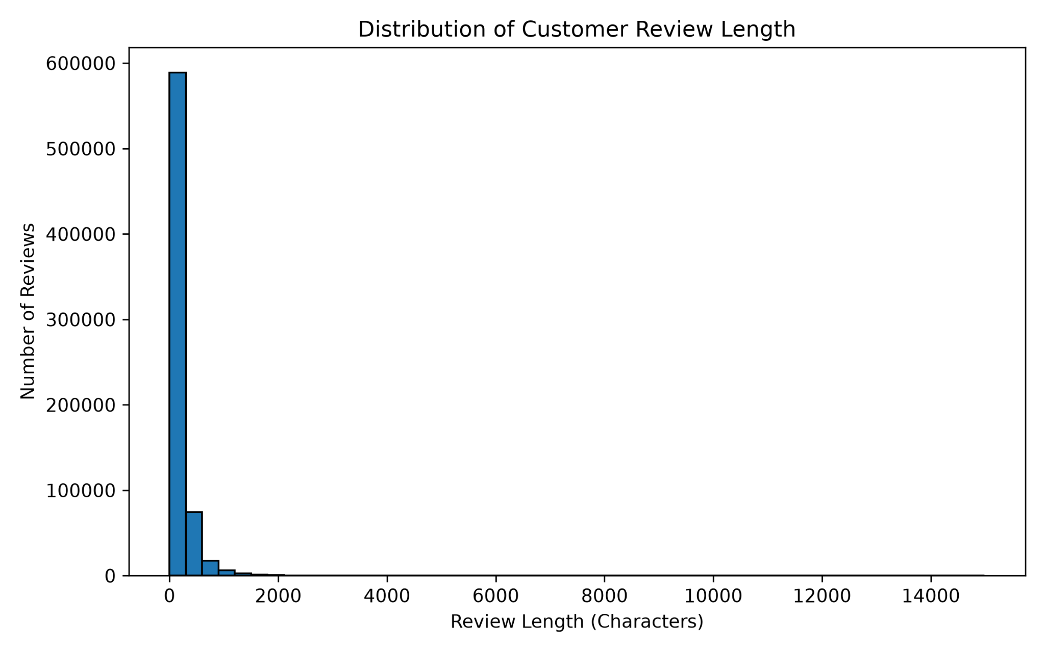
Figure 2. Review-length histogram; verify it against the final generated summary.

12. Output Files and Project Organization

Summary CSV outputs
The script writes `week4_missing_values_summary.csv`, `week4_rating_distribution.csv`, `week4_review_length_summary.csv`, and `week4_reviews_with_length.csv` under `data/processed/`. These files separate numerical findings from the narrative report and allow the results to be checked or reused in later work.

What each file contains
The missing-value summary stores one row per column with the number of null values. The rating distribution file stores the count for each rating value. The review-length summary stores descriptive statistics for the calculated length. The enriched dataset is a copy of the cleaned reviews with an additional `review_length` column. These files should be regenerated whenever the input dataset or analysis logic changes.

Visualization outputs
The script saves `week4_rating_distribution.png` and `week4_review_length_distribution.png` under `visuals/`. The figures are written at 300 DPI and can be included in the Word/PDF report, README, or project presentation. The screenshot folder `Week-4/screenshots/` should contain relevant evidence of execution and generated charts if required by the internship submission process.

Recommended folder layout
The expected project structure includes `Week-4/eda_analysis.py`, `Week-4/README.md`, `data/processed/beauty_reviews_cleaned.csv`, the generated CSV summaries under `data/processed/`, and the two chart images under `visuals/`. The actual path should be confirmed against the repository, because the script derives the project root from its own file location.

Submission quality check
After running the script, confirm that every expected output exists and has current content. Open the rating CSV and verify its total, inspect the review-length summary, and compare the chart labels and range with those values. If data files are large, consider repository size and licensing before publishing them to a public GitHub repository.

13. Reproducibility, Errors, and Quality Assurance

Run command
From the project root, the README command is `python Week-4/eda_analysis.py`. This assumes the script is stored under `Week-4/` and that the cleaned CSV exists in the expected project-relative path. Running from an unrelated folder may expose path assumptions if the code is later modified to use the current working directory.

Expected console output
The run should print the dataset shape, column names, data types, dataset information, descriptive statistics, rating distribution, review-length statistics, output locations, exact rating counts, total ratings, and total dataset rows. The supplied screenshot shows the completion message and an exit code of zero, indicating that the displayed execution ended without a reported Python exception.

Common errors and responses
A `FileNotFoundError` usually means the input file is absent or the project path is wrong. A `ValueError` from the required-column check means that `rating` or `text` is missing. If an output CSV is open in a spreadsheet application, the operating system may prevent overwriting it. Close the file and rerun the script if a permission error occurs.

Checks before finalizing
The most important validation steps are: confirm the row count from `df.shape`; ensure rating values fall in the expected 1–5 range; count null values after numeric conversion; verify that rating counts sum to the number of valid ratings; compare the maximum review length to the histogram; and confirm that the README and report use the same numbers as the fresh output files.

Limitations of a zero exit code
A successful exit confirms that the script completed its statements, but it does not automatically validate the accuracy of every statistic or written interpretation. A script can run successfully on an unexpected dataset, use stale input, or produce outputs that are internally inconsistent. Data validation is therefore part of the analysis, not merely an optional reporting step.

14. Limitations, Ethics, and Risks

Dataset representation
The results describe the records in the supplied dataset. They should not automatically be generalized to all customers, all brands, all beauty products, or all marketplaces. The dataset’s selection process and temporal coverage have not been fully evaluated in this EDA phase.

Rating imbalance
The dominance of five-star ratings can affect interpretation and any future model trained on ratings as labels. A model could appear accurate by predicting the majority class while performing poorly on less frequent ratings. Future evaluation should examine each class and use appropriate metrics rather than accuracy alone.

Text-length limitations
Character count does not indicate whether a review is useful, truthful, positive, negative, or readable. A short review such as a few words can still convey strong sentiment, while a long review may include mixed opinions. Length should be treated as a descriptive feature, not as a substitute for sentiment analysis.

Privacy and responsible presentation
The dataset may contain user or product identifiers. Reports and public charts should avoid exposing individual-level identifiers unless they are essential and permitted. The current charts aggregate rating counts and review lengths, which is more appropriate for a high-level report than reproducing personal identifiers or entire user records.

Avoiding unsupported conclusions
The report does not claim that the project has completed sentiment modelling, discovered product causes, or verified the authenticity of reviews. Any later findings should distinguish raw observations, calculated metrics, interpretation, and limitations. This keeps the project transparent and makes it easier for an evaluator to reproduce the work.

15. Next Steps and Conclusion

Recommended next steps
Before moving to more advanced analysis, rerun the script against the current cleaned CSV and reconcile all outputs. Then examine rating proportions and review-length statistics from the exported files. If the next project phase requires text analysis, document preprocessing choices such as handling punctuation, case, stop words, language, and missing text. Preserve the original review text so transformations can be audited.

Possible extensions
Potential extensions include comparing review length across ratings, visualizing percentages alongside counts, examining ratings by product where sufficient data exists, extracting frequent terms, and preparing a documented sentiment-analysis workflow. These should be treated as future work until their code and outputs have actually been produced and verified.

Conclusion
Week 4 established an initial descriptive view of the Beauty & Wellness customer-review dataset. The script inspects the dataset structure, calculates missing-value counts, summarizes ratings, calculates character lengths, generates two visualizations, and saves reusable CSV outputs. The displayed terminal output indicates 693,443 rows, a dominant five-star category, and a right-skewed review-length distribution with a reported maximum of 14,989 characters.

Final submission checklist
Before uploading: (1) rerun `eda_analysis.py`; (2) verify the final dataset row count; (3) confirm exact rating counts in the CSV; (4) check the review-length maximum and histogram range; (5) inspect all output files; (6) update the README with verified values; (7) include the latest screenshots; and (8) make sure the report, README, CSVs, and charts agree. The final report should reflect one consistent execution, not a mixture of values from different drafts.

Appendix: Technical Interpretation and Verification

How the rating percentages are calculated
The percentage for a rating category is calculated by dividing that category’s count by the total number of valid rating records and multiplying by 100. For example, the five-star proportion is 415,896 divided by 693,443, multiplied by 100, which is approximately 59.98%. Percentages should be recalculated from the current CSV rather than copied manually if the input dataset changes. When invalid or missing ratings are present, the denominator should be the number of valid ratings, not automatically the total number of rows.

How to interpret the review-length summary
The mean describes the arithmetic average, while the median describes the middle observation after sorting lengths. When the mean is greater than the median and the histogram has a long right tail, a small number of long reviews may be pulling the average upward. The quartiles provide additional context: approximately 25% of lengths are at or below the first quartile, and approximately 75% are at or below the third quartile. These summaries help characterize the distribution but do not identify the content or quality of any individual review.

Suggested reproducibility commands
From the project root, run `python --version` to record the interpreter version, `python -m pip show pandas matplotlib` to record the direct library versions, and `python Week-4/eda_analysis.py` to execute the analysis. After execution, inspect the terminal output and open the four CSV outputs. The rating counts in the terminal and CSV should agree. The maximum in the review-length summary should agree with the full-range histogram. If any value differs, check that the same input CSV was used and regenerate all outputs before editing the report.

Evidence management
Keep the latest terminal screenshot and chart images in the Week-4 evidence folder. Use clear filenames and avoid mixing screenshots from different executions. The report should describe only operations visible in the code or verified in the output. If a chart is updated, replace the older chart in the report and README as well. This simple version-control practice reduces the risk of submitting a report whose text, numbers, and visual evidence describe different versions of the analysis.

